NOTICE OF MEETING
BOARD OF DIRECTORS OF THE
CEDAR HILL COMMUNITY DEVELOPMENT CORPORATION
GOVERNMENT CENTER
4TH FLOOR CONFERENCE ROOM
285 UPTOWN BLVD
THURSDAY, SEPTEMBER 5, 2013
6:00 P.M.
AGENDA

I. Call the meeting to order.

II. Citizens forum.

III. Approve regular CDC minutes of June 27, 2013.

V. Receive and discuss design concepts for the FM 1382 Core Trail.

VI. Receive an update on ongoing projects.

VII. Consider meeting dates for a workshop to develop a 5 year CIP.

VIII. Adjourn

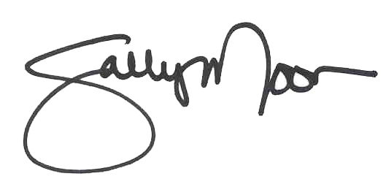
I certify that the above copies of notice were posted at the Cedar Hill Government Center at 5:00 p.m. Friday, August 30, 2013.

_____________________________________

This facility is wheelchair accessible. Handicapped parking spaces are available. Requests for sign interpretive services must be made 48 hours ahead of meeting. To make arrangements, call 291-5100 ext 1010 or (TDD) 1-800-RELAY TX (1-800-735-2989).

